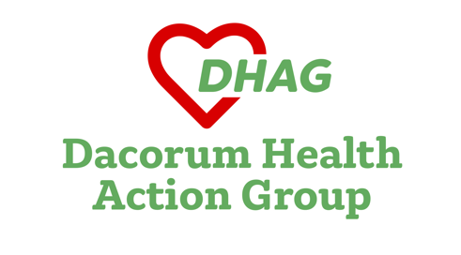
WEST HERTFORDSHIRE HEALTH ISSUES
DHAG Newsletter January 2024
Hemel Hempstead Health Campus – a step forward?
The population of Dacorum is on the rise. 11,000 more homes are planned in Hemel Hempstead alone by 2050. Numbers of people over 65 could grow by 35% in the next 20 years. This will sharply increase demands on our health services, including hospitals.
So there was some excitement when Dacorum Borough Council and the NHS, including the West Hertfordshire Teaching Hospitals Trust, announced in November that they were working towards the creation of a purpose-built integrated Health Campus in the former Market Square in Hemel Hempstead.
However, the development would mean the closure of the current Hemel Hempstead Hospital, and the final end for hospital beds in the town. There is no guarantee at all that a new building would mean increased hospital services.
This is because current NHS plans for Hemel Hospital don’t take sufficient account of rising demand in Dacorum. For instance, the NHS plan to provide for just a tiny 6.3% increase in cases at the Hemel urgent treatment centre over 15 years, while the Watford General Emergency Department is to see a 30% rise in cases. The result - more and more journeys for Dacorum people to the inaccessible building site known as Watford General.
NHS plans are inadequate to meet Dacorum’s long-term needs. There must be a proper independent assessment of those needs before any decision is taken on the location of NHS services in the Borough.
Trust deficits threaten Watford General development plans
The Government’s programme of building 40 new hospitals by 2030 is floundering across the country as Trust deficits increase, jeopardising financing plans. But the West Herts Trust will have a particularly difficult problem in building a new facility at Watford General.
The Trust is likely to post a big deficit of about £20 million at the end of the current financial year, March 31. It wants to spend £1.3 bn on Watford General – one of the most expensive projects in the whole New Hospital Programme, with three tall tower blocks. Unfortunately, the Trust has a turnover of just £500 million, much smaller than other trusts who are aiming to build big new premises. So it cannot afford to stretch itself financially.
In May 2022 the Trust’s Chief Financial Officer warned that it needed to break-even to ensure its redevelopment plans were affordable. There is no chance of that happening any time soon. It is now obvious that the Trust will struggle to get Treasury approval for the project. Even if it does, deep cuts to our vital hospital services will be necessary to fund the tower blocks.
The NHS needs to explore better alternatives on new sites before the Watford situation deteriorates further.

Watford General’s A and E performance – four-hour waits get worse
Watford General Hospital’s A and E came 119th out of 122 in England on the key four-hour wait measure for the most serious cases in December 2023. Only 37% of such ‘Type One’ patients were admitted, transferred or discharged within the target four hours, way below the English average of 54% and nowhere near the target of 95%.
This was the worst figure for Watford since December 2022.
Performance on ambulance turnaround is more mixed. Over 87% of handovers at Watford took over 15 minutes, among the worst in the country, but the percentage of handovers that took 60 minutes or more (6.9%) compares reasonably well with some other hospitals.

A Trust that doesn’t represent Dacorum
Most of the major decisions about hospital services for the people of Dacorum are taken by a Board which does not represent the Borough. Not one of the eight non-executive directors of the West Hertfordshire Hospitals NHS Trust has a main home in Dacorum.
Why does this matter? It matters because ‘non-execs’ have an important role in the NHS, providing an outsider’s view and (supposedly) scrutinising the work of the officials (basically civil servants) who manage the day-to-day running of the Trust. Non-execs need to understand local health needs. NHS England policy is set out on its webpage:
We are interested in hearing from people from a range of backgrounds who understand the needs and priorities of their local communities and can hold the confidence of patients and the public.
And how does the West Herts Trust define ‘local’? There are non-execs on the Board from almost every Borough in Hertfordshire – except Dacorum, the biggest, with a population of 155,000. The principle followed by our hospital Trust is simple: when it comes to people influencing the future of our hospitals, it is ABD - Anywhere But Dacorum.
Dacorum Health Action Group (DHAG) brings together local people campaigning for better healthcare across the Borough of Dacorum. The website is https://dhag.org.uk/about-us/

