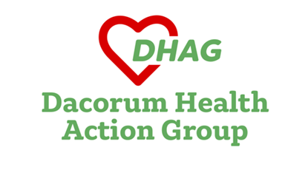
23 May 2026

I am Chair of Dacorum Heath Action Group, which, as you know, campaigns for better health care for the people of the Borough.
I am writing to express our concern at new evidence of the rundown in locally-accessible hospital services for the people of Dacorum. For the past 20 years or so, there has been a gradual withdrawal of acute services from Hemel Hempstead Hospital.
This process has now reached a serious stage. The last meeting of the West Hertfordshire Teaching Hospitals Trust Board considered proposals for a reduction in the number of nursing and clinical support staff deployed at the outpatients department at Hemel Hempstead Hospital. This would save £271,000 annually, which would be applied at the outpatients at St Albans City Hospital.
This switch of resources away from Hemel is justified in the Board papers because of low ‘service demand’. On average, there are approximately 125 patients seen daily at Hemel outpatients, ‘representing a significant reduction against planned volumes’ according to the papers. They continue: ‘This sustained gap between planned and actual activity suggests that the current staffing and clinic configuration at HH exceeds observed service demand.’
No explanation is given for the failure to achieve planned levels of appointments. There is certainly no evidence provided here that patients are unwilling to use Hemel Hospital. The shortfall appears to be driven by the Trust itself, whether as a matter of senior management policy, individual choices by clinical departments, or for other reasons.
Meanwhile, St Albans City Hospital outpatients department is extremely busy, with an average of 224 patients per day. This means that, in an average week, there are, it seems, nearly 500 more appointments at St Albans Hospital outpatients than at Hemel. Given the very limited parking arrangements at St Albans, this must be straining the system and making access more complicated. Bus services are not always reliable. The Trust papers refer to ‘projected growth’ at St Albans outpatients, so the access problems are likely to get worse.
One key aim of Government policy has been to bring care closer to home. The imbalance between the number of appointments at Hemel and at St Albans means that your constituents may well be travelling further than is necessary for hospital care. This is pushing care further away from home – exactly the opposite of what should be happening.
I would be grateful if you would raise with the Trust, and, if necessary, Ministers, the continued rundown of local NHS services for your constituents. The key question in relation to the latest developments concerns the reasons for the failure to provide enough appointments for people at Dacorum’s only remaining NHS Hospital.

Yours sincerely

Philip Aylett
Chair
Dacorum Health Action Group

